Implement Nakagami Distribution of MATLAB in NetSim without using .m file

In this project we will replace the default Rayleigh Fading (part of the path loss calculation) used in NetSim, with a Fading Power calculated using the Nakagami Distribution from MATLAB.

# Steps to run MATLAB Interfacing Code in NetSim:

1. Create a MATLAB_Interface.c file inside the WLAN folder which can be found in the path <NetSim_Install_Direcotry>/src/Simulation/.

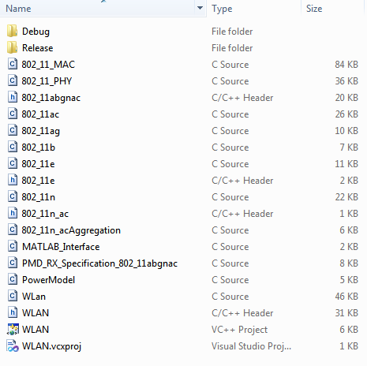

1. Write the following code inside the MATLAB_Interface.c file:-
2. /*
3. *
4. * This is a simple program that illustrates how to call the MATLAB
5. * Engine functions from NetSim C Code.
6. *
7. */
8. #include <windows.h>
9. #include <stdlib.h>
10. #include <stdio.h>
11. #include <string.h>
12. #include "engine.h"
13. #include "mat.h"
14. #include "mex.h"
15. char buf[100];
16. Engine *ep;
17. int status;
18. mxArray *h=NULL, *i=NULL, *j=NULL,*k=NULL;
19. mxArray *out;
20. double *result;
21. double fn_matlab_init()
22. {
23. /*
24. * Start the MATLAB engine
25. */
26. if (!(ep = engOpen(NULL))) {
27. MessageBox ((HWND)NULL, (LPCWSTR)"Can't start MATLAB engine",
28. (LPCWSTR) "MATLAB_Interface.c", MB_OK);
29. exit(-1);
30. }
31. engEvalString(ep,"desktop");
32. return 0;
33. }
34. double fn_netsim_matlab()
35. {
36. //write your own implementation here
37. int nakagami_shape=5,nakagami_scale=2;
39. engPutVariable(ep,"h",h);
40. sprintf(buf,"h=ProbDistUnivParam('nakagami',[%d %d])",nakagami_shape,nakagami_scale);
41. status=engEvalString(ep,buf);
43. engPutVariable(ep,"i",i);
44. sprintf(buf,"i=random(h,1)");
46. status=engEvalString(ep,buf);
47. out=engGetVariable(ep,"i");
48. result=mxGetPr(out);
49. return *result;
50. }
51. double fn_netsim_matlab_Finish()
52. {
53. status=engEvalString(ep,"exit");
54. return 0;

}

1. Now open WLAN project file, inside the WLAN folder.

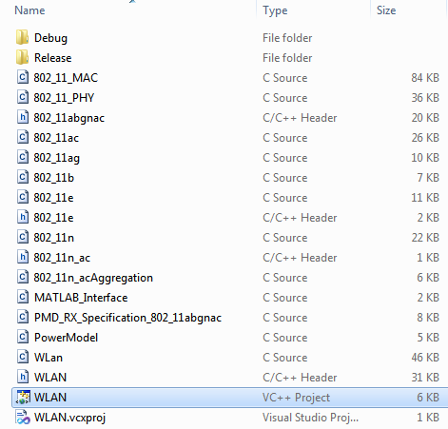

1. Right click on WLAN project🡪Add🡪 Existing Item🡪 Select MATLAB_Interface.c file.

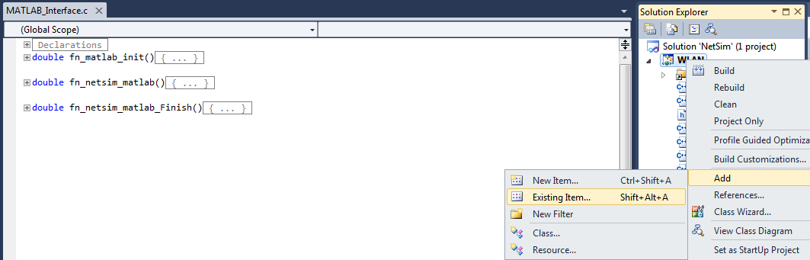

1. Open WLan.c file and add fn_matlab_init() and fn_netsim_matlab_Finish() inside fn_NetSim_WLAN_Init () and fn_NetSim_WLAN_Finish () respectively.

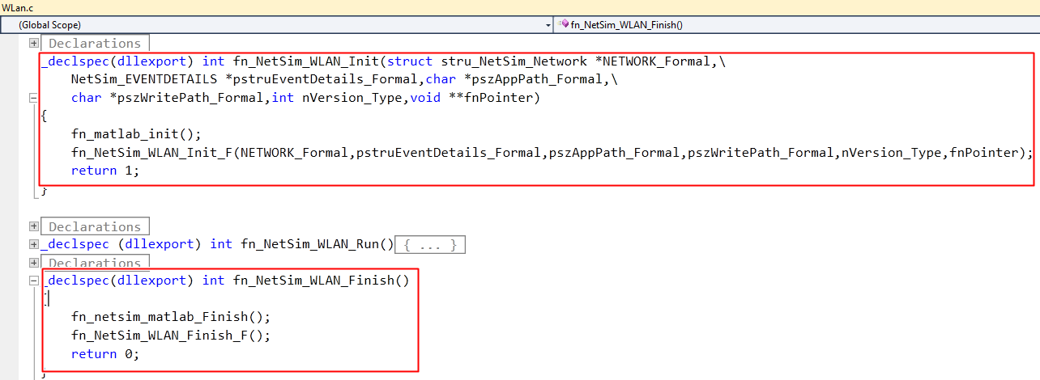

1. Add definitions of the following functions inside WLAN.h file

double fn_matlab_init();

double fn_netsim_matlab();

double fn_netsim_matlab_Finish();

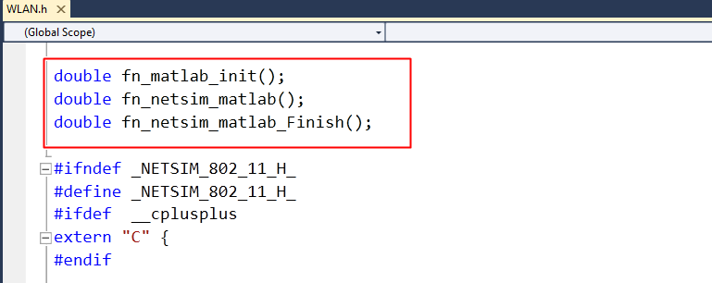

7. Go to the 802_11_PHY.c file. Inside fnCalculateFadingLoss() function comment the lines,

*dFadingPower = log(*dFadingPower);

*dFadingPower= 10*log10(-*dFadingPower);

And also Make a call to the fn_netsim_matlab() function by adding the following line,

*dFadingPower = fn_netsim_matlab();

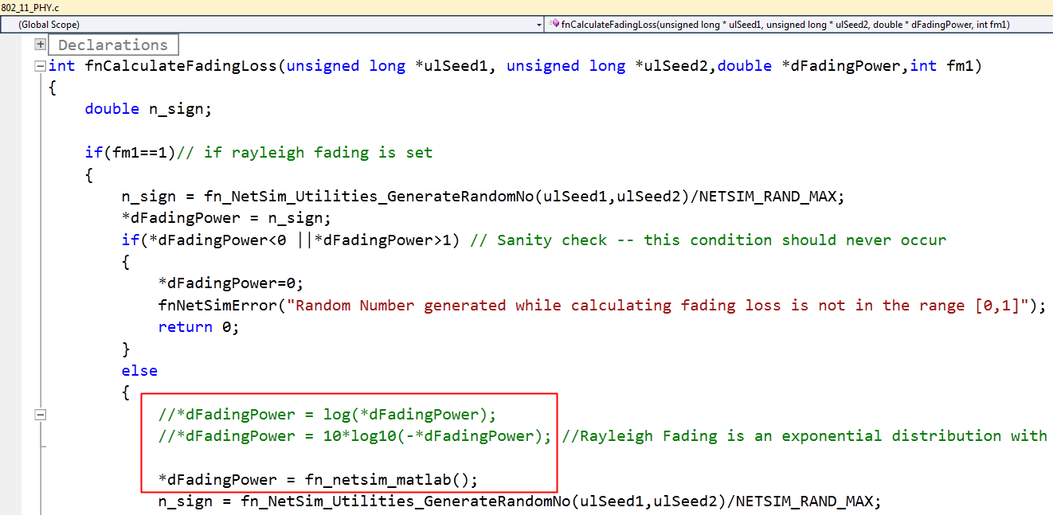

1. To compile a MATLAB engine application in the Microsoft Visual Studio 2010 environment, Right click on the WLAN project and select PROPERTIES in the solution explorer. Once this window has opened, make the following changes:

**a.** Under C/C++ General, add the following directory to the field ADDITIONAL INCLUDE DIRECTORIES:

<Path where MATLAB is installed>\extern\include

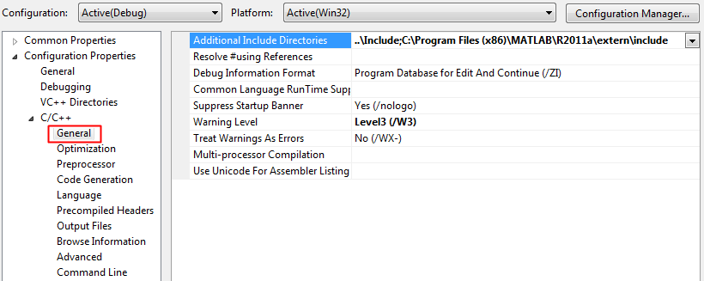

**b.** Under C/C++ Precompiled Headers, select "Not Using Precompiled Headers".

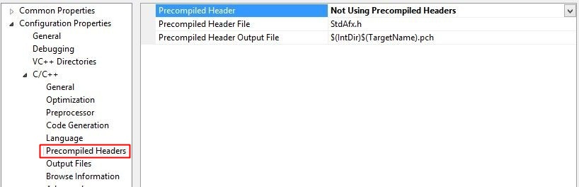

**c.** Under Linker General, add the directory to the field ADDITIONAL LIBRARY DIRECTORIES:

<Path where MATLAB is installed>\extern\lib\win32\microsoft

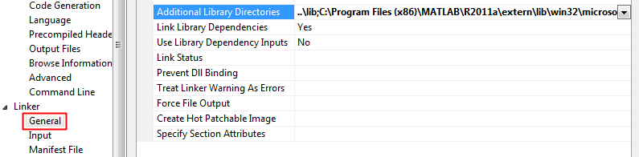

**d.** Under Configuration Properties ->Debugging

Add the following Target path in the *Environment*:

<Path where MATLAB is installed>\bin\win32

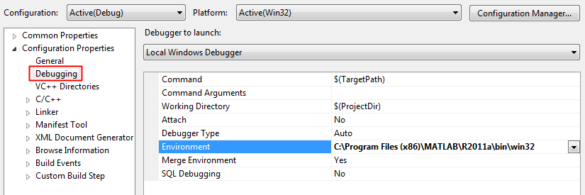

**e.** Under Linker Input, add the following names to the field marked ADDITIONAL DEPENDENCIES:

libmx.lib; libmat.lib; libeng.lib by separating them with a semicolon.

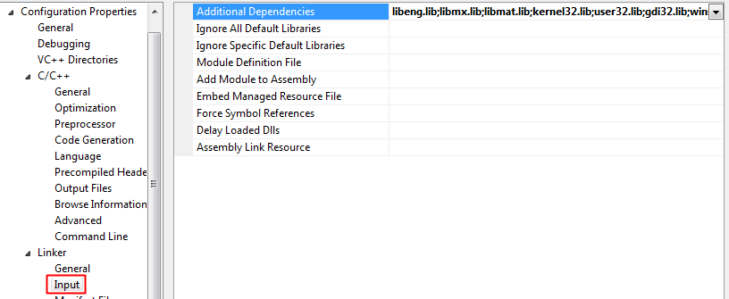

Click on Apply and then on ok.

**f.** Make sure that the following directory is in the PATH(Environment variable)

<Path where MATLAB is installed>\bin\win32

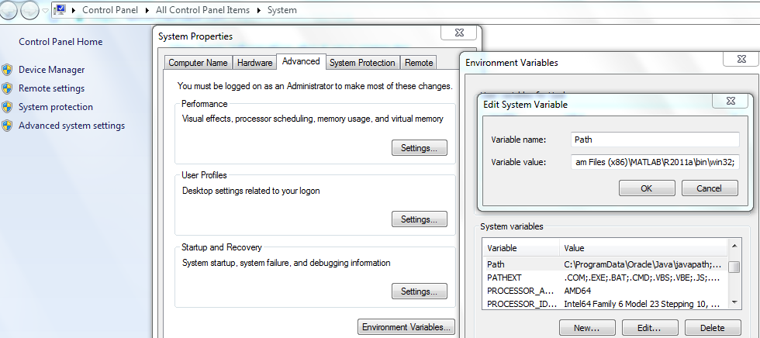

**NOTE:**

To run this code 32- bit version of MATLAB must be installed in your system.

1. Now Right Click on WLAN project and select Rebuild.
2. Now replace the newly built libWLAN.dll from the DLL folder, into the NetSim bin folder. Please ensure you rename the original libWLAN.dll file to retain a copy of the original file.
3. Run NetSim in Administrative mode. Create a Network scenario involving WLAN say MANET.

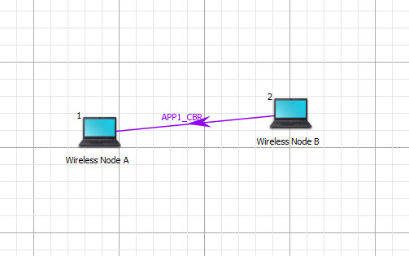

1. Set the Fading Figure value in the Multipoint to Multipoint Link properties to 1, to ensure that Rayleigh fading is set.

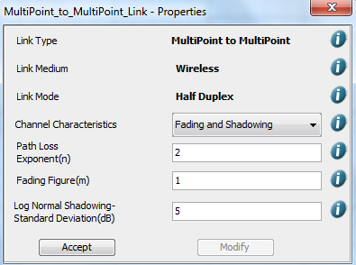

1. Perform Simulation. You will find that once the Simulation starts MATLAB command window starts and gets closed once the simulation is over.